Every BCP leaves our workshop with proof.
Inspection, measurement, testing and documentation are built into every overhaul and rewind, so you can hand your evidence, not just a repaired unit.
Introduction
A boiler circulation pump cannot be trusted on appearance. Its condition has to be measured, and its repair has to be verified before it returns to a unit that depends on it.
At DEI VOX, quality isn’t a final inspection. It runs through the whole job, from incoming inspection and teardown measurements to controlled repair, testing and documentation. For service companies working with overseas customers, this gives you records you can pass on with confidence.
Certified Management Systems
Our certifications:
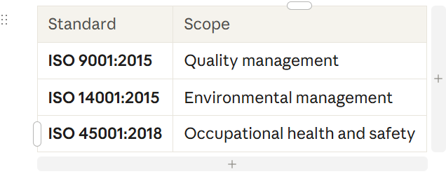
Buttons: View Certificates (PDF) · Download Quality Policy

. Our Quality Process, Step by Step
- Incoming inspection. The unit is received, logged, photographed and checked against your nameplate and paperwork. Damage in transit is recorded immediately.
- Pre-work checks. Initial electrical and mechanical readings are recorded before teardown.
- Teardown and measurement. Components are tagged and measured against design values. Wear, damage and likely root causes are documented with photographs.
- Scope approval. Findings and our recommendation go to you before repair begins. Nothing proceeds without your approval.
- Controlled repair. Work follows documented procedures, and materials and consumables are matched to the job [confirm traceability practice.
- In-process checks. Critical dimensions, fits and clearances are verified at key stages.
- Final testing. Tests are carried out and recorded, as described below.
- Final inspection and release. The job record is reviewed before the unit is released for packing.
- Packing and dispatch. Export-ready packing with a documentation pack.

Testing We Perform
Pump overhaul
- Dimensional inspection of critical parts against design values
- Clearance and fit verification at assembly
- Dynamic balancing of the rotating assembly
- Non-destructive examination of repaired or critical components
- Hydrostatic pressure test
- Vibration or run test
Motor repair and rewinding
- Insulation resistance and polarisation checks
- Winding resistance measurement
- High-voltage and surge testing
- Hydrostatic test of the motor pressure boundary
- Rotor balancing and vibration checks
- No-load test
Inspection Options for Customer
If customer or their inspector wants to see the work, we can accommodate it
- Customer or inspector witness at key hold points, in person
- Remote witness by live video
- Third-party inspection, by an agency nominated by you
- Hold points and inspection plan agreed before work starts

Confidentiality and Data Protection
- Your drawings, reports and test data stay confidential. We sign your NDA on request, and we use your technical information only to deliver your job.

- Frequently Asked Questions
- Which standards do you work to? Our management systems are certified to ISO 9001:2015, ISO 14001:2015 and ISO 45001:2018. For technical acceptance, we follow the design values, your specifications or the applicable standard for each job [
- Can my customer witness the tests? Yes. We can arrange in-person, remote or third-party witness, with hold points agreed in advance.
- What does the test report include? The tests carried out, the measured values, the dates and the personnel or approvals involved.
- Are your test instruments calibrated? Yes, at defined intervals, with records kept
- Do you issue certificates of conformity for parts? Yes.
- How long do you keep the records for my job? 10 years.
- What happens if a test result is outside tolerance? We stop, inform you, explain the options and agree the next step before continuing.
- Do you offer a warranty on repaired units? Same as standard OEM Warranty.
CTA Button: [Explore Our Services] | [Submit an RFQ]

